**DAILY ONLINE ACTIVITIES SUMMARY**

|  |  |  |  |  |  |  |  |  |
| --- | --- | --- | --- | --- | --- | --- | --- | --- |
| **Date:** | **31-05-2020** | | | | | **Name:** | **Nachiketh S Bhat** | |
| **Sem & Sec** | **6th - B** | | | | | **USN:** | **4AL17CS119** | |
| **Online Test Summary** | | | | | | | | |
| **Subject** | | **--** | | | | | | |
| **Max. Marks** | | **--** | | **Score** | | | **--** | |
| **Certification Course Summary** | | | | | | | | |
| **Course** | **BLOCKCHAIN ESSENTIALS** | | | | | | | |
| **Certificate Provider** | | | **IBM** | | **Duration** | | | **8 of 10** |
| **Coding Challenges** | | | | | | | | |
| **Problem Statemen:1.** Count of pairs in an Array whose sum is Prime | | | | | | | | |
| **Status: executed** | | | | | | | | |
| **Uploaded the report in Github** | | | | | **yes** | | | |
| **If yes Repository name** | | | | | <https://github.com/nachi0106/Daily-Activity/tree/master/Online-coding%20report/31-05-20> | | | |
| **Uploaded the report in slack** | | | | | **Yes** | | | |

Certification Course Details

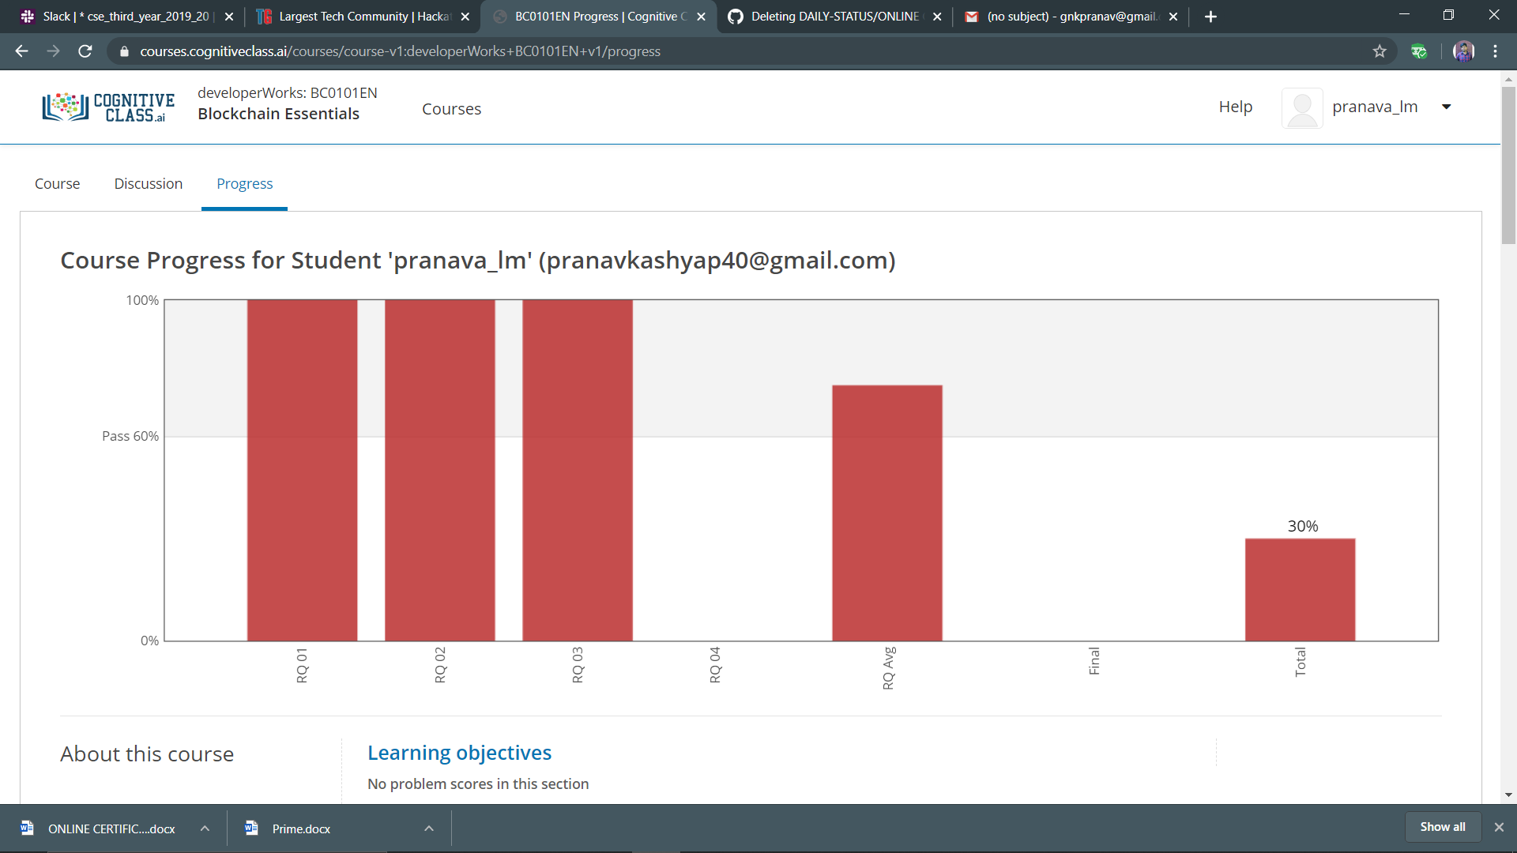

Program output

